**Marine Traffic**

**Transport Trackers| 23.09.2023**

# Executive Summary

MarineTraffic is a web-based tool that provides real-time ship tracking information. The tool uses Automatic Identification System (AIS) data to track the movements of commercial ships, tankers, and other vessels around the world. MarineTraffic is a valuable tool for businesses and individuals who need to track the location of ships or monitor maritime traffic.

This tool report provides a comprehensive overview of the installation, execution, scope, and limitations of the MarineTraffic tool. The report also includes recommendations for how to use the tool effectively.

# Index

**Executive Summary 2**

**Index 2**

**1. Introduction 2**

**2. Tool Details 2**

**3. Installation 3**

**4. Execution 3**

**5. Scope and Limitations 3**

**6. Conclusion 3**

**7. References (if any) 4**

# Introduction

MarineTraffic is a web-based tool that provides real-time ship tracking information. The tool uses Automatic Identification System (AIS) data to track the movements of commercial ships, tankers, and other vessels around the world. AIS is a transceiver system that automatically broadcasts a ship's position, identification, and other information to nearby ships and shore-based stations.

MarineTraffic provides a variety of features, including:

* Real-time ship tracking: MarineTraffic allows users to track the location of ships in real time. Users can view the positions of ships on a map, as well as information about the ship's name, type, speed, and heading.
* Historical ship tracking: MarineTraffic also allows users to view the historical ship tracking data for any ship. Users can see where a ship has been in the past, as well as its speed and heading.
* Ship information: MarineTraffic provides detailed information about each ship, such as its name, type, size, and flag. Users can also view photos and videos of ships.
* Port information: MarineTraffic provides information about ports around the world, such as their location, contact information, and arrival and departure times for ships.

# Tool Details

It is a web based tool

Website: <https://www.marinetraffic.com/>

# Installation

MarineTraffic is a web-based tool, so there is no need to install any software. To use the tool, simply visit the MarineTraffic website and create an account.

# Execution

Once you have created an account, you can start using the MarineTraffic tool to track ships. To track a ship, simply enter the ship's name, IMO number, or MMSI number into the search bar and click "Search." MarineTraffic will then display the ship's position on a map, as well as information about the ship's name, type, speed, and heading.

You can also use the MarineTraffic tool to track ships by area. To do this, simply click on the "Map" tab and zoom in on the area that you want to track. MarineTraffic will then display all of the ships in the area, as well as their positions and information.

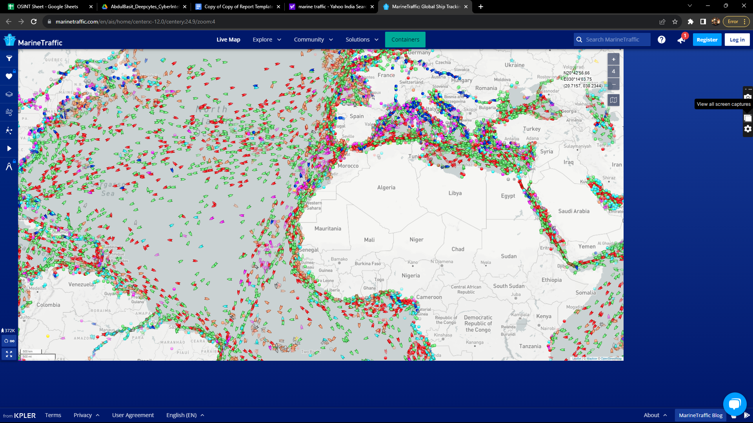

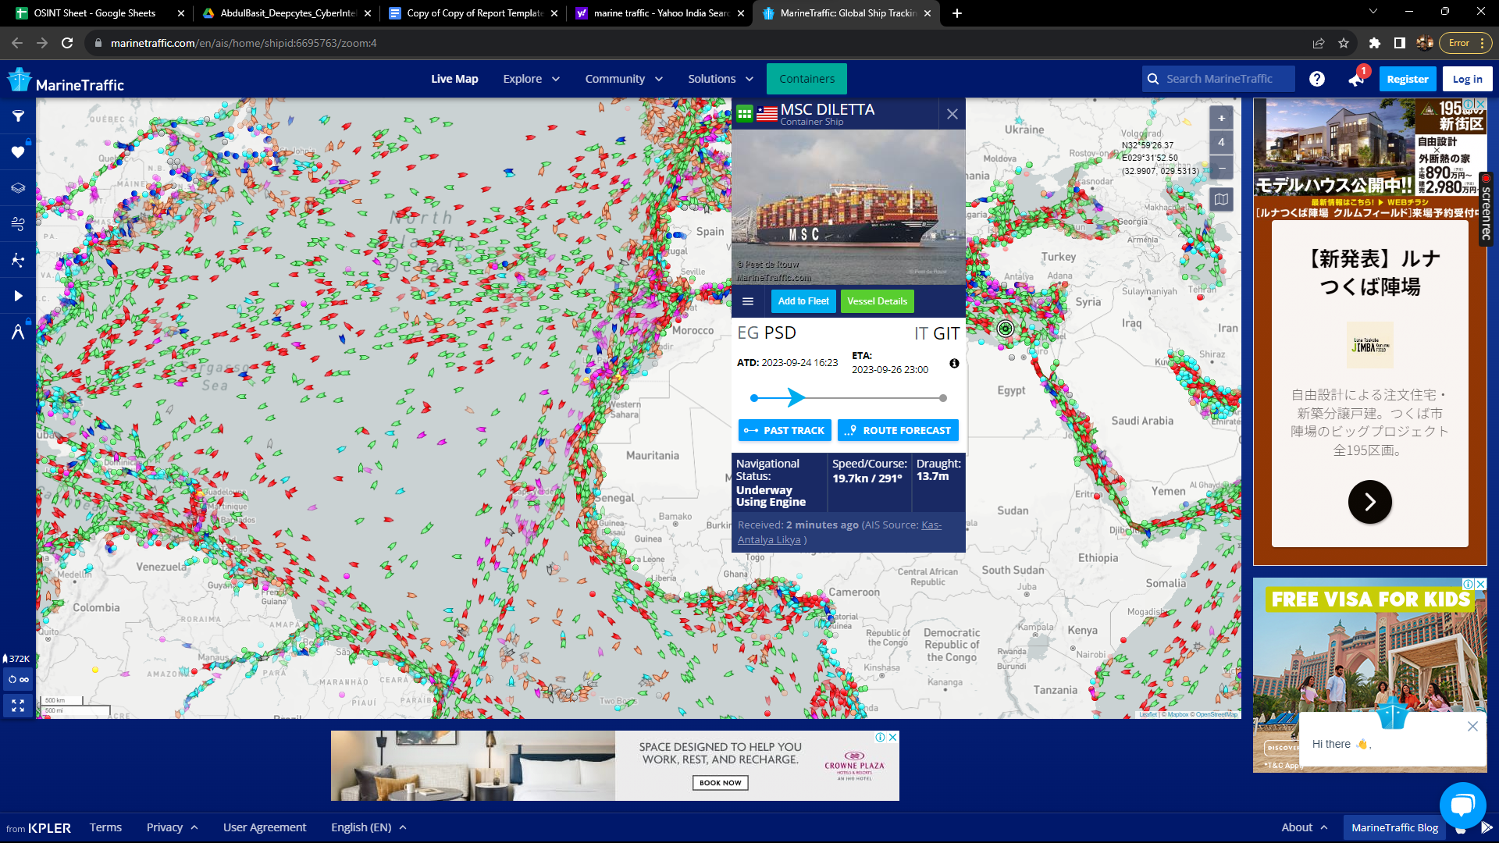

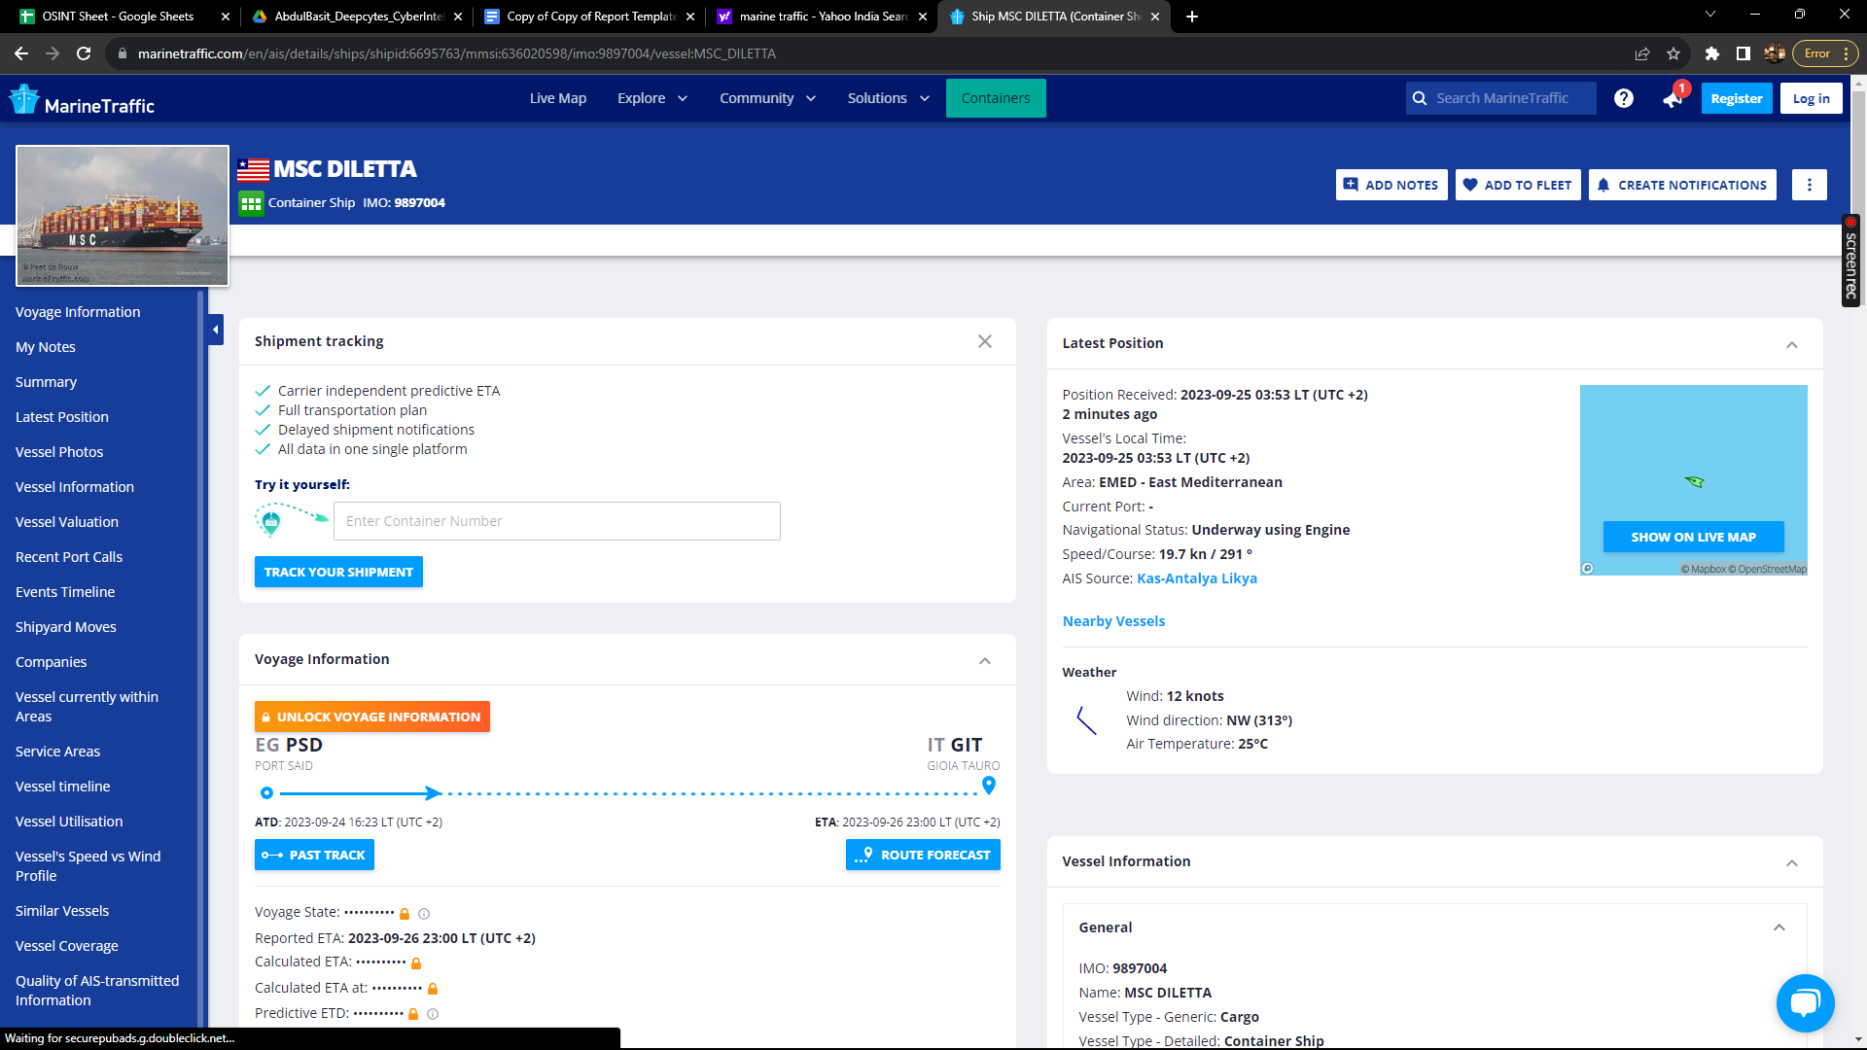

# Scope and Limitations

MarineTraffic is a powerful tool for tracking ships and monitoring maritime traffic. However, it is important to be aware of the limitations of the tool.

MarineTraffic can only track ships that are equipped with AIS transceivers. Not all ships are equipped with AIS transceivers, so MarineTraffic will not be able to track all ships.

Additionally, MarineTraffic cannot guarantee that the information that it displays is accurate or up-to-date. It is possible that the information that MarineTraffic displays may be incorrect or out of date.

# Conclusion

MarineTraffic is a valuable tool for businesses and individuals who need to track the location of ships or monitor maritime traffic. The tool is easy to use and provides a variety of useful features. However, it is important to be aware of the limitations of the tool before using it.

# References

Content